

# **Paylink Important Concepts and Integration**

Table of Contents

**Paylink Important Concepts and Integration** 1

**1. Introduction** 2

**1.1 Paylink Hardware Explaination** 2

**1.2 Paylink Device LED Status Indications** 3

**1.3 Hardware Installation** 3

**2. Using PayLink** 5

**2.1 How to get it working?** 5

**2.2 How to integrate with custom project?** 5

**2.3 How to connect Switch** 6

# **1. Introduction**

## **1.1 Paylink Hardware Explaination**

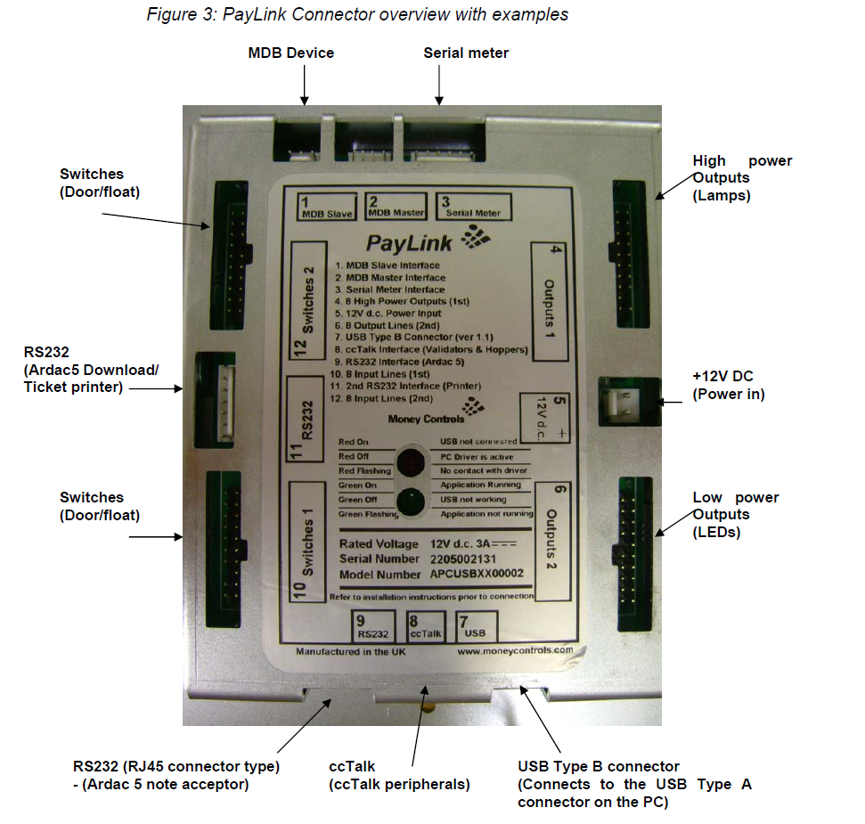

The above figure is showing the Paylink connections. Before Proceeding further please clearly understand the Paylink Device options available.

## **1.2 Paylink Device LED Status Indications**

|  |  |
| --- | --- |
| **RED** on | USB not connected (electrical) |
| **RED** off | PC driver is active |
| **GREEN** off | USB not working |
| **RED** flashing | No contact with PC driver program |
| **GREEN** flashing | Application not running |
| **GREEN** on | Application running & Peripherals |

## **1.3 Hardware Installation**

It is very easy to install the CCTALK with coin mech, coin acceptor and with despenser.

|  |  |
| --- | --- |
| Connect the ccTalk multi drop cable to **PayLink** | Connect the SR5 cable to the ccTalk multidrop cable and SR5. |
|  |
| Connect the 4 X 20-way headers to the I/O connectors | Connect **PayLink** to the 2-pin power cable and to a +12V dc power supply. The status LED  will show **RED ON** |
| Connect the USB cable to **PayLink** and to the PC. | |

# **2. Using PayLink**

You can download all of the Distribution files from following link and copy all files in the C:/ drive . <http://www.cranepi.com/en/products/view/147/tab:support#tabs> or check my uploaded files with this documentation

## **2.1 How to get it working?**

1. Copy Files to the JAVA Home/ bin
   1. 
   2. 
   3. 
   4. 
   5. 
2. Copy Driver file  to C:\Windows\System32\drivers
3. **AESWDriver.exe** (the PayLink driver, you need to keep it running before doing anything)
4. **Firmware.exe (**upgrade program to latest firmware)
5. **Demo.exe** (Run test program and check that the device is working)

## **2.2 How to integrate with custom project?**

From download resources page you will find one tester program in Java as well. There is small piece of code that gives you an idea that how you can play with API. The AesImehei.jar (C:\PayLink Distribution\SDK\Java) library will give you an access to the API. So you create a new project and add that file into the project library that we will use later on.

## **2.3 How to connect Switch**

There are 20 places available on the PAYLINK Board to connect switch. It is the actual switches indexes are starting from 0 - 7 and 8-15 (Bottom to top at input side).

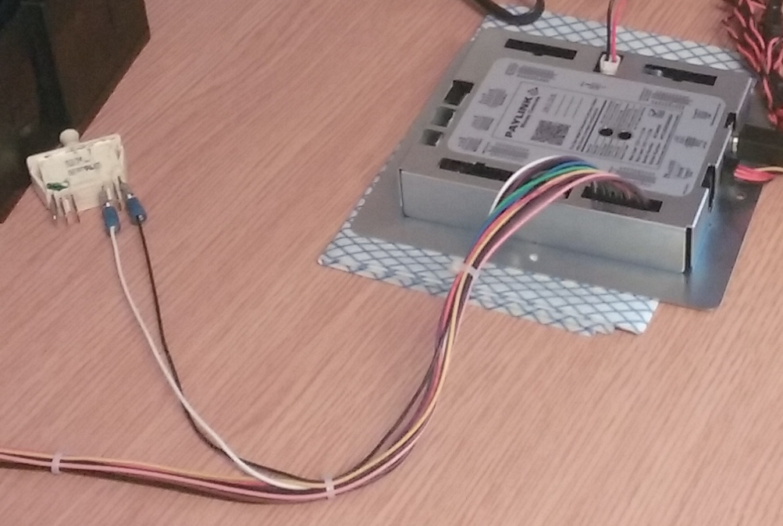

After that check the switch code in sample code.